**Project:**

Chatbot using IBM Cloud Watson Assistant

**Phase-II:**

Innovation

Submitted by

Name: CG Nikhil

Nm id:au723921244012

Mail id: cgsunny345@gmail.com

**What is Natural Language Understanding?**

NLU is understanding the meaning of the user's input. Primarily focused on machine reading comprehension, NLU gets the chatbot to comprehend what a body of text means. NLU is nothing but an understanding of the text given and classifying it into proper intents.

**INNOVATION:**

Implementing Natural Language Understanding (NLU) in a chatbot to achieve accurate user intent recognition involves a series of steps.

**INNOVATION STEPS:**

**Select an NLU Service:**

Choose an NLU service or framework that fits your needs. Popular options include IBM Watson Natural Language Understanding, Google Cloud Natural Language, Microsoft Azure Text Analytics, and custom-built NLU models using libraries like spacey or NLTK.

**Gather and Annotate Training Data:**

Collect a diverse dataset of user queries or sentences that represent the types of interactions your chatbot will handle. Annotate the training data with labels for intents and entities. Annotating data typically involves labelling each sentence with the corresponding intent and marking any entities within the sentences.

**Pre-process and Clean Data:**

Prepare the training data by removing noise, standardizing text, and addressing issues like misspellings. Pre-processing ensures that the data is in a consistent format for training.

**SYSTEM ARCHITECTURE:**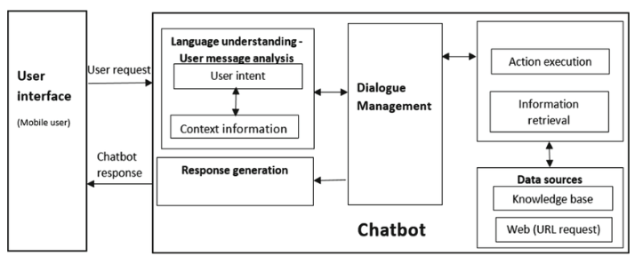

**Train Your NLU Model:**

Use the annotated training data to train your NLU model. The specific process may vary depending on the NLU service or framework you choose. For custom models, you may use machine learning algorithms like Naive Bayes, support vector machines, or deep learning techniques like LSTM or BERT.

**Evaluate Model Performance:**

After training, evaluate the NLU model's performance using a separate validation dataset or cross-validation techniques. Measure metrics like precision, recall, and F1-score to assess how well the model recognizes intents and entities.

**Integration with Your Chatbot:**

Integrate the trained NLU model into your chatbot system. Most NLU services provide APIs or SDKs for this purpose. When a user sends a query to the chatbot, pass the query to the NLU model to extract the intent and entities.

**Intent Recognition and Response Generation:**

Based on the intent recognized by the NLU model, the chatbot can determine how to respond to the user's query. This might involve routing the user to a specific dialog flow or generating an appropriate response.

**Context Management:**

Keep track of the conversation context and previous user inputs to ensure accurate intent recognition within the context of the conversation. Context management is crucial for handling multi-turn dialogues.

**Continuous Training and Improvement:**

Continuously collect new data and retrain your NLU model to adapt to changing user input patterns. Regularly monitor the chatbot's performance and gather user feedback to identify areas for improvement.

**User Feedback and Iteration:**

Encourage users to provide feedback and use their input to fine-tune your NLU model and enhance intent recognition.

**Error Handling and Fall backs:**

Implement error handling and fall-back mechanisms in case the NLU model fails to recognize an intent accurately. This can involve asking clarifying questions or providing default responses. As your chatbot gains more users and handles larger volumes of data, ensure that your NLU system can scale accordingly.

By following the above steps and continuously improving your NLU model and chatbot, you can achieve more accurate user intent recognition, resulting in a more effective and user-friendly chatbot experience, and we also experience lots of new features of the chatbot

### 

### **Key Features:**

1. **Adaptive Personal**
2. **Recommendations**
3. **Detail explanation by multimedia**
4. **Real-time Translation**
5. **Multi language support**
6. **Integration with AR/VR:**

### **Emotional Intelligence**:

